Program and output of derivation of sigmoid function:

sigmoid_derivation.py

import matplotlib.pyplot as plt
import math
import numpy
y = []
x = numpy.arange(-5,5,0.1) #array range from -5 to +5 with interval of 0.1
for i in x:
val = 1/(1+math.exp(-i))
val = val * (1 - val)
y.append(val)
plt.plot(y)
plt.show()

Graph Output:

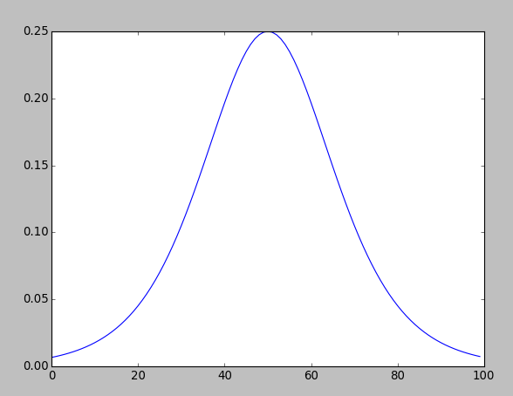

Program and output of derivation of hyperbolic tangent function:

tangent_derivation.py

import matplotlib.pyplot as plt
import math
import numpy
y = []
x = numpy.arange(-5,5,0.1) #array range from -5 to +5 with interval of 0.1
for i in x:
val = (math.exp(i)-math.exp(-i))/(math.exp(i)+math.exp(-i))
val = 1 - val**2
y.append(val)
plt.plot(y)
plt.show()

Graph Output:

